**HOW TO AVOID PAYING FOR A WEBSITE   
THAT LOOKS LIKE POO**

**8 real-life lessons for small businesses**



Last month, two separate clients contacted me within half an hour of each other. Both were beside themselves.

They don’t know each other, but they certainly know each other’s pain; paying good money for a website they hate. Or as one of the two clients phrased it so eloquently, a website that ‘*looks like poo’*!

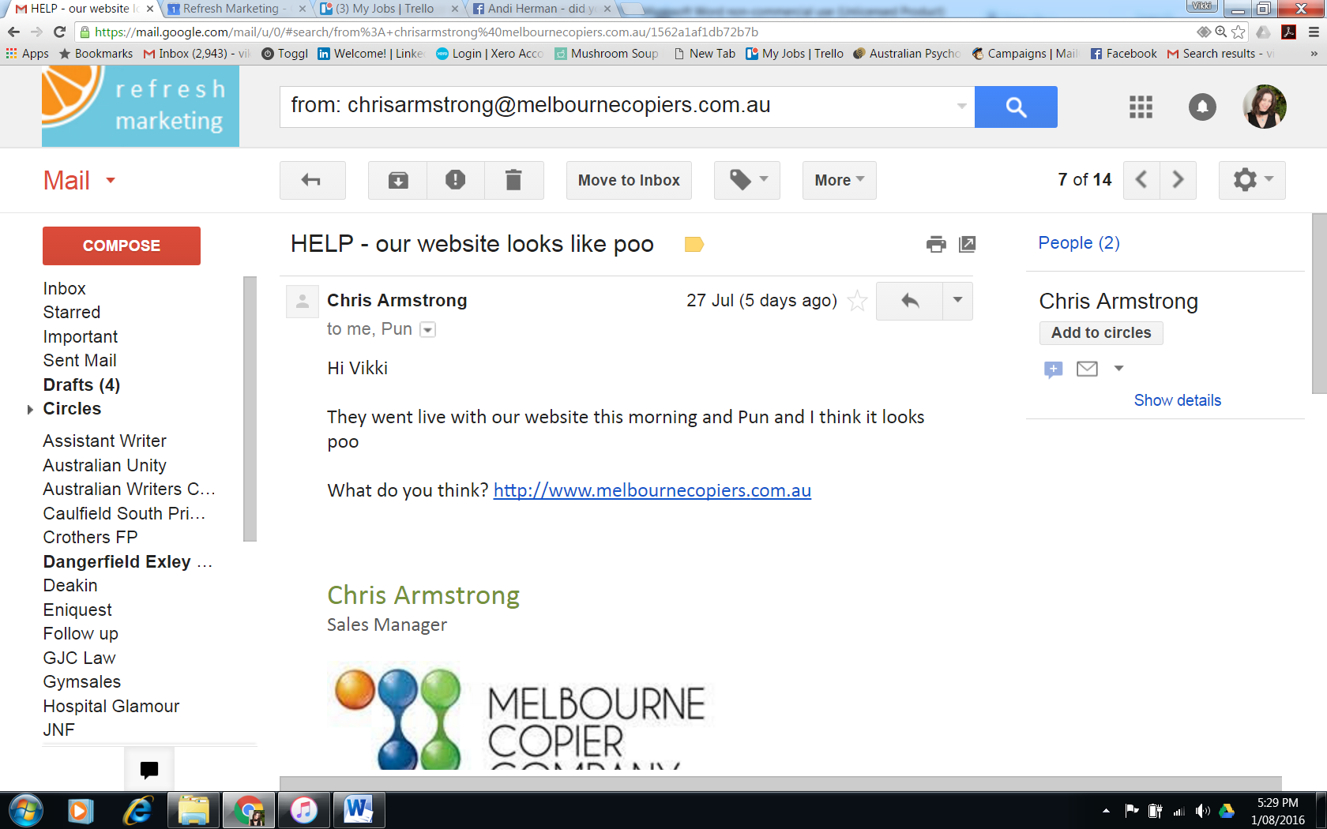

In both cases, I had seen red flags waving wildly – well before the websites began to take shape. (But I knew better than to utter those familiar, futile words of parents the world over: ‘*I told you so’*.)

I’m the first to say that it’s rare to receive calls like this twice in one day. But I get them more often than you might think. Often enough to know how many dodgy so-called ‘digital agencies’ are out there exploiting unsuspecting, ill-informed small businesses.

And boy, does it make me mad.

Obviously I am a website copywriter, not a website designer. But as a communications professional, I always want my client to have the best possible finished product. And nothing makes me cringe more than seeing my carefully crafted words slapped online without a trace of design integrity.

Over the years, I’ve seen clients make every mistake in the book when hiring a web designer – and the outcomes were never pretty.

Here are eight of my best (or worst) true stories along with some important lessons for you to take away.

**Don’t become the client who… PAID PEANUTS**

I almost fell off my chair when one client revealed the amount she paid her website designer. Here goes.

$400.

Yup, you read correctly. $400.

No wonder her website looked awful. And no wonder the service had been abominable. The only solution for this client was to farewell her four hundred and move on. Sure, it’s not a lot of money to lose, but the whole palaver sapped her time and energy. What small business owner needs that?

*Lesson #1: Don’t get seduced by super-cheap web design deals. Quality always comes with a price. So how cheap is too cheap? Small businesses should expect to pay at least $2,000 for a professionally produced website. But realistically, closer to $3,000.*

**Don’t become the client who… NEVER SAW OR SIGNED OFF ON A DESIGN**

Remember that website I mentioned earlier in this post? The one that looked like *poo*?

That poor client was blindsided the day their website went live.

When I asked who signed off on the design and why they didn’t run it past me earlier, they informed me that this was also *their* first glimpse of the site redesign. That’s right. Their website was designed, built and *published* without any client input whatsoever.

Un-freaking-believable.

*Lesson #2: Website production is a two-stage process: 1) design 2) development (or build). Under no circumstances should your website designer move to stage two until you are 100% satisfied with stage one. And your new site should never GO LIVE until you give the explicit go-ahead.*

**Don’t become the client who… HIRED A TECHIE TO CREATE THEIR WEBSITE**

Newsflash: Website design and website development aren’t synonymous. They are two very different skills. And it’s extremely rare to find someone who can do both well.

This particular client hired WordPress developer who chose a template, whacked on their logo and plonked in the text – applying zero design finesse.

Here’s the thing. I believe that back-end developers should never take the lead on design. The uglier websites you’ve come across were probably created solely by developers, with no input from a designer at any stage.

*Lesson #3: Ensure your website team includes a designer as well as a developer. Your designer will determine your site’s look and feel (i.e. branding, colours, imagery and so on) and your developer will build your site**– making sure it functions as it should.*

**Don’t become the clients who HIRED A STUDENT/NEPHEW/COUSIN/FRIEND TO DESIGN THEIR WEBSITE**

I’ve witnessed many horror stories about businesses that entrust their company website to a student – or to someone they’re connected to personally.

One client in particular engaged their *uber-talented* nephew… who also happened to be a student (yup, two in one). But the worst part? He wasn’t even studying a relevant qualification. He was an industrial design student with no experience designing websites.

Another client engaged their cousin’s new husband, probably out of obligation. And when my client was disappointed with the initial designs, she felt she had no choice but to just ‘go with it’ to keep the family peace.

Then there was the client who paid a major university good money to be a real-life guinea pig for a group of second year design students. And guess what? She ended up with a final product she couldn’t use.

*Lesson #4: Don’t engage inexperienced students or people you know personally – just because you can. Keep it commercial and professional at all times. Mate’s rates and family favours should come second.*

**Don’t become: the client who… HIRED A DOOR-KNOCKER**

The website game is cluttered and cut-throat. And some fly-by-nighters go to great lengths to win business.

This is the story of a client who chose a company simply because they appeared on their doorstep at the right time.

Big mistake.

Their website ended up looking rubbish. What’s more, the company that built it disappeared off the face of the earth a couple of months later. And because the site was built using a proprietary CMS (rather than an open source platform such as WordPress), my client had no option but to start from scratch.

Time and money down the drain once again.

*Lesson #5: Only consider web designers that have already performed work for someone you know and trust. It’s no guarantee of course, but it’s better than going for someone off the street. Surely.*

**Don’t become the client** **who… (ALMOST) ENGAGED SOMEONE WITH NO PORTFOLIO**

Last year, I managed to stop one client from engaging a web designer who was just starting out. Not because he was a newbie. But because he had no portfolio to speak of.

After a little undercover work (thanks, LinkedIn…), I discovered that their new website ‘designer’ had been a real estate agent for 20 years – until six weeks earlier.

Scary, I know.

Of course everyone has to start somewhere and there’s nothing wrong with giving a newbie a break. But being new to the game is no excuse for not having a portfolio. I know several designers who created websites for family and friends at no cost to establish credibility *before* entering formal commercial arrangements.

A word of warning however. Having a portfolio isn’t enough. Take the time to scrutinise it by asking yourself:

*Do you like their style?*

*Are their designs creative and engaging?*

*Does the portfolio show diversity across brands and industries?*

And if you see a website in their portfolio that you particularly like, ask the designer how much that other client paid. If it’s a lot more than you’re willing to spend, you won’t get the same quality.

*Lesson #6: Make sure your website designer has a meaty portfolio with plenty of examples of sites you like. And if you don’t have an eye for design, get the opinion of someone who does.*

**Don’t become the client who…LAUNCHED A WEBSITE THAT DOESN’T REFLECT THEIR BRAND. AT ALL.**

This client engaged me to write and oversee the design of a new corporate brochure (not their website). And as part of that process, I needed to look at all their existing communications first to get a feel for their branding.

So it was early on when I discovered that their (newly launched) website looked nothing like any of their other marketing materials. Hell, it didn’t even include their logo.

When I asked my client how their business managed to get by for 30 years without a corporate logo (which is what I had understandably assumed), she assured me they did have one. It just never occurred to the web designer to ask for it.

Had they done so, they would have seen that their corporate colour was navy. Not pastel green.

Need I say more?

*Lesson #7: Be sure that your designer takes an interest in your brand identity and asks to see all your existing marketing materials before starting the design process.*

**Don’t become the client who… HIRED A DEVELOPER THAT DIDN’T WANT TO MEET THEM**

Last year, one of my clients was underwhelmed with the first cut of her new website design.

It happens. But that shouldn’t necessarily mean it’s a lost cause.

However, when she asked her *developer* (yes, he was a techie – see Lesson #3) to meet up to discuss the design and clarify her vision, he declined, stating that email was his preferred form of communication.

Sometimes when novices dislike a design, their reasoning is not immediately clear to them. They just know it’s not right. That’s why you need a provider who’s willing to thrash it out with you.

In this instance, my client decided to move on and engage someone else. Messy financial dispute ensued.

*Lesson #8: Choose someone that’s a clear, open communicator. They should be invested in the relationship – not just the transaction.*

**But please, don’t be disheartened. I see many happy stories too.**

In recent years, I have formed strong relationships with a small handful of web designers that I now recommend to my clients with complete confidence.

Put simply, they get it right time and again.

It was a deliberate strategy on my part – and an attempt to provide a more complete solution to my clients which they value immensely.

Everyone wins.

**Have you had a bad experience with a web designer? What lessons did you learn that others may benefit from?**